###### VISVESVARAYA TECHNOLOGICAL UNIVERSITY,

**BELGAUM- 590014**



**A Mini Project Report**

**On**

**Archer Fish**

Project Report submitted in partial fulfillment of Sixth semester

**Bachelor of Engineering in**

Computer Science and Engineering

**Submitted By**

### priy ranjan 2bv09cs077

**MANISH SINGH 2BV08CS044**

**ROHIT RAJ 2BV09CS082**

**SHARADHISHRI D. 2BV09CS091**

**SHUBHASHINI B. 2BV09CS099**

**Under the guidance of**

**Prof. Mahesh Patil**

.



Department of Computer Science and Engineering

B.V.B. COLLEGE OF ENGINEERING & TECHNOLOGY,

HUBLI – 580 031 (India).

**(An Autonomous Institution affiliated to VTU, Belgaum)**

Academic year 2011-12

K.L.E. SOCIETY’S

**B.V. BHOOMARADDI COLLEGE OF ENGINEERING & TECHNOLOGY, HUBLI -580031**

**(An Autonomous Institution affiliated to VTU, Belgaum)**

2011 - 2012



DEPARTMENT OF COMPUTER SCIENCE & ENGINEERING

**Certificate**

This is to certify that project entitled Archer File is a bonafied work carried out by the student team Mr. Priy Ranjan (2bv09cs077-USN), Mr. Manish Singh (2bv08cs059–USN), Mr. Rohit Raj (2bv09cs082–USN), Ms. Sharadhishree D. (2bv09cs091-USN), Ms. Shubhashini B. (2bv09cs108 – USN), in partial fulfillment of the award of degree of Bachelor Engineering in Computer science and Engineering during the year 2011 – 2012. The project report has been approved as it satisfies the academic requirement with respect to the project work prescribed for the above said programme.

**Guide H.O.D**

**Prof. Mahesh Patil Prof. K.R.Biradar**

**External Viva:**

**Name of the Examiners Signature with date**

**1.**

**2.**

**ABSTRACT**

**ACKNOWLEDGEMENTS**

The successful completion of the project is not complete until and unless we thanks the guiding pillars behind the project.

We would like to express our sincere thanks to our Head of the Department, Computer Science **Prof. K.R Biradar** for all the necessary support.

We thankfully acknowledge the help we received from project in-charges **Prof. Vijay Biradar, Prof. Mahesh Patil and Prof. Shruti Hedge** for guiding us in project work in accordance with University requirements.

Team Members:

### priy ranjan 2bv09cs077

MANISH SINGH 2BV08CS044

ROHIT RAJ 2BV09CS082

SHARADHISHRI D. 2BV09CS091

SHUBHASHINI B. 2BV09CS099

|  |  |  |  |  |  |  |  |
| --- | --- | --- | --- | --- | --- | --- | --- |
| **Chapter No.** | **Table of Contents** | | | | | **Page No.** | |
| **1.** | **Preamble** | | | | |  | |
|  | 1.1 | Introduction………………………………………………… | | | | 7 | |
|  | 1.2 | Problem Definition…………………………………………... | | | | 7 | |
|  | 1.3 | Scope and Objectives……………………………………… | | | | 7 | |
| **2.** | **System Study** | | | | |  | |
|  | 2.1 | Existing System (Advantages and Disadvantages)…………. | | | | 8 | |
|  | 2.2 | Proposed System…………………………………………….. | | | | 8 | |
|  | 2.3 | Advantages of proposed system……………………………... | | | | 8 | |
|  | 2.4 | Constraints…………………………………………………… | | | | 8 | |
| **3.** | **Software Requirement Specification** | | | | |  | |
|  | 3.1 | Introduction | | | |  | |
|  |  | 3.1.1 | | Purpose……………………………………………. | | 9 | |
|  |  | 3.1.2 | | Scope of Project…………………………………… | | 9 | |
|  |  | 3.1.3 | | Intended Audience ……………………………… | | 9 | |
|  |  | 3.1.4 | | References………………………………………… | | 9 | |
|  | 3.2 | Requirement Specification | | | |  | |
|  |  | 3.2.1 | | Functional Requirements ………………………… | | 10 | |
|  | 3.3 | Nonfunctional Requirements | | | |  | |
|  |  | 3.3.1 | | Performance requirements………………………… | | 13 | |
|  |  | 3.3.2 | | Safety requirements……………………………….. | | 13 | |
|  |  | 3.3.3 | | Software Quality Attributes……………………….. | | 13 | |
|  |  | 3.3.4 | | User Documentation………………………………. | | 13 | |
|  | 3.4 | External Interface Requirements | | | |  | |
|  |  | 3.4.1 | | User Interfaces…………………………………… | | 15 | |
|  |  | 3.4.2 | | Hardware Interfaces……………………………… | | 23 | |
|  |  | 3.4.3 | | Software Interfaces………………………………. | | 23 | |
| **4.** | **System Design** | | | | |  | |
|  | 4.1 | Architectural Design (overview of the system and related h/w and s/w details…………………………………………... | | | 23 | |
|  | 4.2 | Detailed Design | | |  | |
|  |  | 4.2.4  4.2.5 | Flow Chart………………………………….  Data structure description…………………………. | | 24  25 | |
|  | 4.3 | User Interface Design | | |  | |
|  |  | 4.3.1 | User interface overview …………………………... | | 25 | |
|  |  | 4.3.2 | User interface navigation hierarchy……………….. | | 27 | |
| **5** | **Implementation** | | | |  | |
|  | 5.1 | Module description with its input and output……………… | | | 28 | |
| **6** | **Testing** | | | |  | |
|  | 6.1 | Test plan and Test cases……………………………………. | | | 31 | |
| **7** | **Results**……………………………………………………………… | | | | | 36 | |
| **8** | **Conclusion and future scope**……………………………………… | | | | | 38 | |
| **9** | **References/Bibliography**………………………………………… | | | | | 38 | |
|  |  | | | | |  | |
|  |  |  | | | |  | |

## 1. PREAMBLE

* 1. **Introduction**

With the increasing market of android applications there is a growing demand of new games on the platform.

*Archer fish* is an android based game that simulates shooting skills of archer fish. An archer fish shoots its prey with sprays of water and eats it after it falls down into the water. *Archer Fish* has been designed with this particular behavior of actual archer fishes in consideration.

* 1. **Problem Definition**

To develop Archer Fish game, for android based devices, which simulates the shooting action of archer fish i.e. shoot water bubbles at the prey flying near water and eat the fallen down insect.

* 1. **Scope and Objectives**

With the sole intention of player’s entertainment in mind, the objective of game is to aim and shoot at prey, which then falls in to water and is eaten by the fish.

The game has been intended for an audience of all the ages kids, youngsters, elderly people.

**2. System Study**

**2.1 Existing System**

Archer Fish games already exist on java platforms. Also these games are available on iOS platform.

**2.1.1 Advantages of Existing Systems**

* The currently existing games on archer fish are more widely used on PCs.

**2.1.2 Disadvantages of Existing Systems**

* The game is not available for android based mobile phones and other handheld devices.
* The simplicity of the games does not provide challenges to the player.

**2.2 Proposed System**

The proposed game, Archer Fish, is portable to the android based mobile phones and other handheld devices. The game simulates the shooting action of the Archer Fish. In this game the fish shoots water bubbles at the prey near water and eats the fallen down insects.

**2.3 Advantages of proposed system**

* In the proposed game the preys are not stationary, which makes the game more challenging for the player and hence more interesting.
* The player can maintain his/her separate profile which will store all their developments in the game.
* The game is portable to any of the android based mobile or other handheld devices.

**2.4 Constraints**

* The game cannot be supported by devices having API level lesser than 10.

**3. Software Requirement Specifications**

**3.1 Introduction**

**3.1.1 Purpose**

The proposed system is an android platform based game which simulates the shooting action of an archer fish. The main purpose of the game is to aim at the prey flying near water and shoot it with water bubble. After the insect is properly hit it falls down into the water and the fish eats it.

**3.1.2 Scope of project**

The scope of the game is to simulate the behavior of an archer fish. The fish can redirect itself to aim at the prey near water and shoot it with the bubble. The insects hit will fall down into the water and the fish will eat them. The player will gain points on both shooting the insects and eating the insects fallen down into the water.

.

**3.1.3 Intended Audience**

The intended audiences of the SRS are developer, evaluator and the customer.

**3.1.4 Reference**

Pankaj Jalote, An Integrated Approach to Software Engineering, 3ed.

**3.2 Requirement Specifications**

**3.2.1 Functional Requirements**

* User should be able to create a new profile.
* User should be view the list of all the previously created profiles.
* User should be able to delete all the existing profiles.
* User should be able to change various settings of the game as per choice and save the settings so that the game can be loaded with the same settings the next time the game is started.
* User should be able to resume the game from the same point he/she left the previous time.
* User should be able to start a new game.
* User should be able to play only the levels that have been unlocked.
* A level is unlocked only if the user successfully completes the previous level.
* User should be able to make the fish shoot insects with water bubbles.
* The insects hit properly with the water bubble should fall down.
* User should be able to make the fish eat the fallen down insects.
* User should gain points on correctly shooting the insect and eating the fallen down insect.
* User should be able to pause the game, resume, and restart the game.
* User should be able to play the same level again or proceed to the next level.
* User should be able to login to Facebook and twitter to update scores and messages.

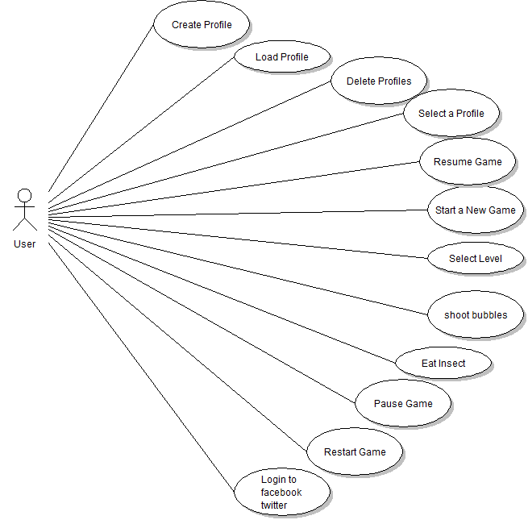

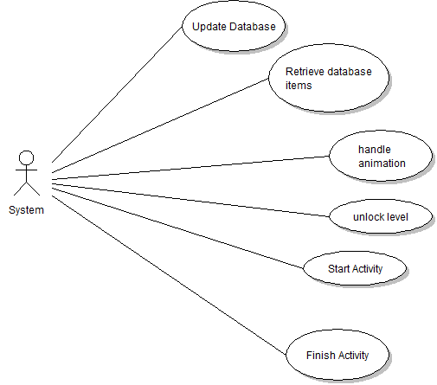

**3.3 Nonfunctional requirements**

**3.3.1 Performance Requirement**

The game is completely device independent and runs smoothly in all the android based devices without any glitches.

**3.3.2 Safety Requirements**

The proposed system is just a game and it does not have any data of utmost importance that needs to be secured. Also it is not a web based application hence it does not pose any virus threats.

**3.3.3 Software Quality Attributes**

The gameplay has been very much simplified, so all types of users can play and enjoy the game.

**3.3.4 User Documentation**

Adequate care has been taken for user documentation making it easy to and play. A few screen shots have been produces here.

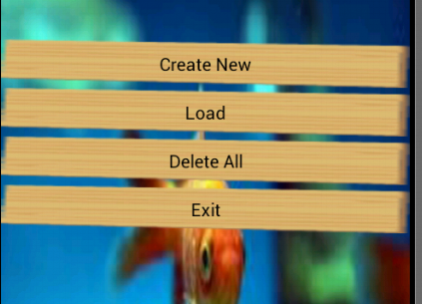

Well documented buttons.

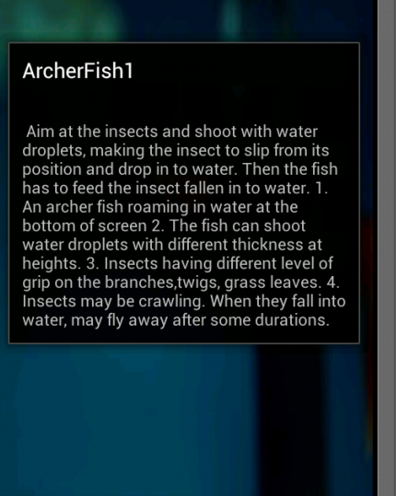

Adequate instructions have been provided to the user regarding what the game is about and how to play it.

**3.4 External Interface Requirements**

**3.4.1 User Interface**

This is the first activity that will start when the game is loaded.gives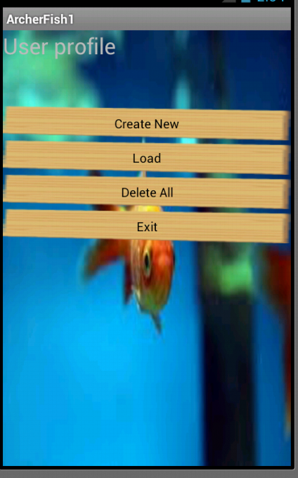

It has 4 buttons to create a new profile, load the existing profiles to delete all the pre-existing profiles or to exit the application.

After the load profile button is pressed this screen appears with the list of all the profiles and their scores in the decreasing order of their scores.

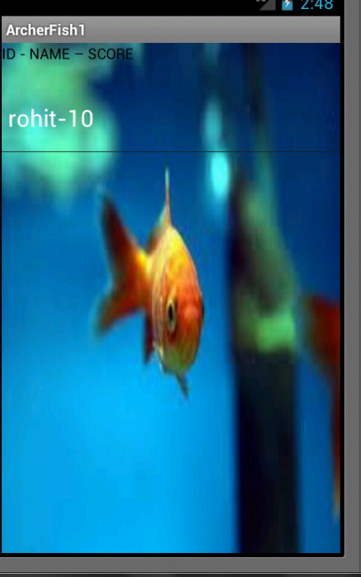

Selecting any of the user profiles will take the player to the game area.

This is the first screen of the profile specific game area with the following buttons: Play, Settings, Instructions and Exit.

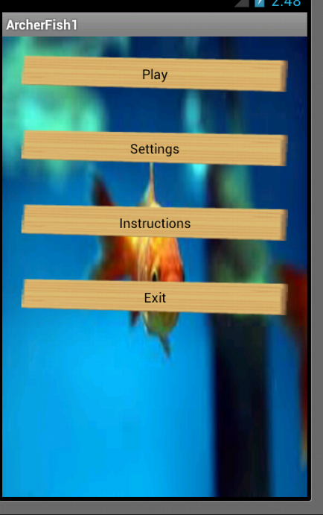

On clicking on the Settings button, the following user settings can be changed.

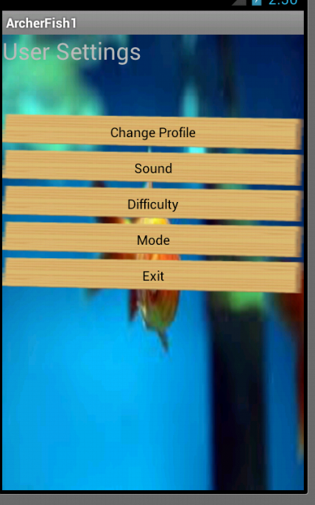

If the user wants to change the mode of diffilcutly the following screen appears with the options to select the difficulty level.

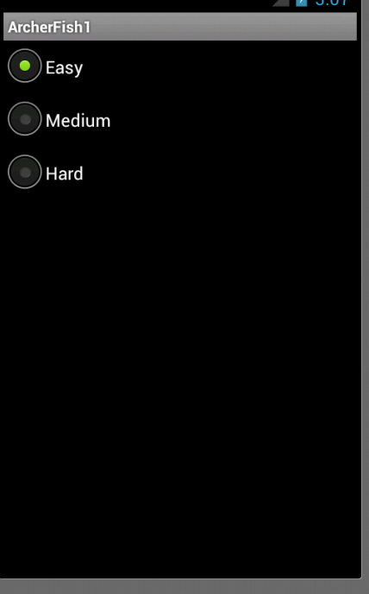

On selecting the play option the following screen appears. The user can either start a new game (by clicking on New Game button) or the user can resume the game from where he/she quit the previous time.

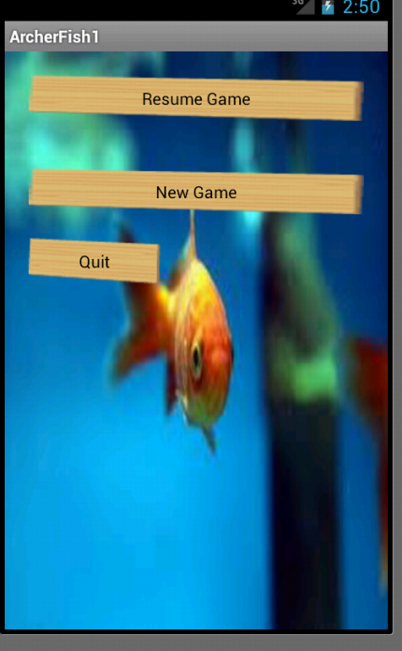

On starting a new game Levels screen will appear, displaying the 6 levels of the game. Only unlocked levels can be played. The locked levels can be played by unlocking completing the previous levels

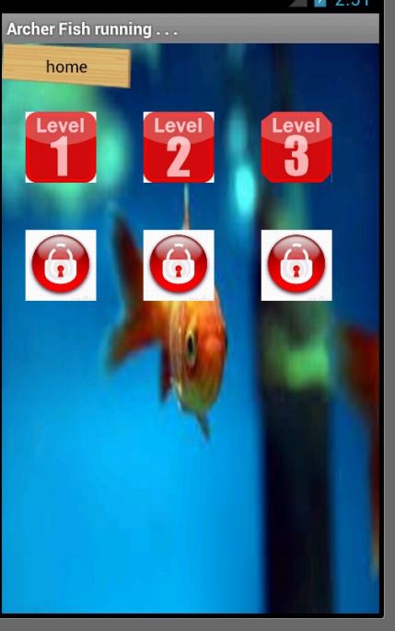

Game Screen appears on selecting a new game or on resuming an old game. The Game Screen consists of flying insects and a fish at the bottom of the screen. It also has a pause button and a button to shoot the bubbles.

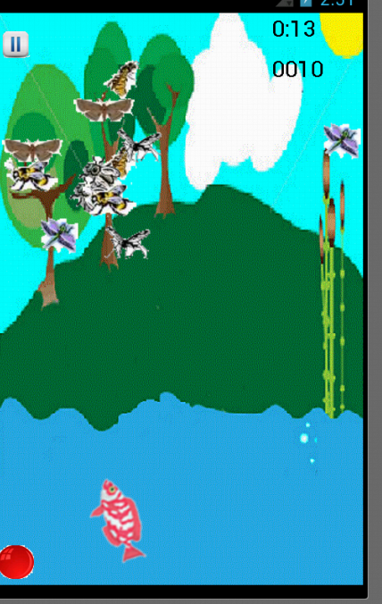

**3.4.2 Hardware Interfaces**

A minimum memory of 15 MB is required on the device and device should be using a minimum of API level 10.

**3.4.3 Software Interfaces**

The software used are Eclipse and android-sdk.

**4. System Design**

**4.1 Architectural Design**

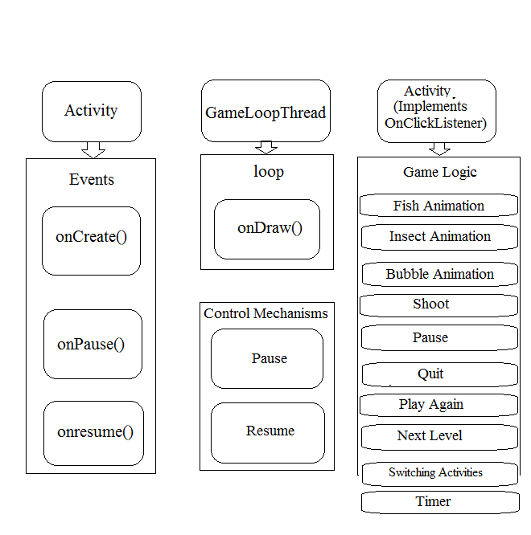

**4.2 Detailed Design**

**4.2.1 Flow Chart**

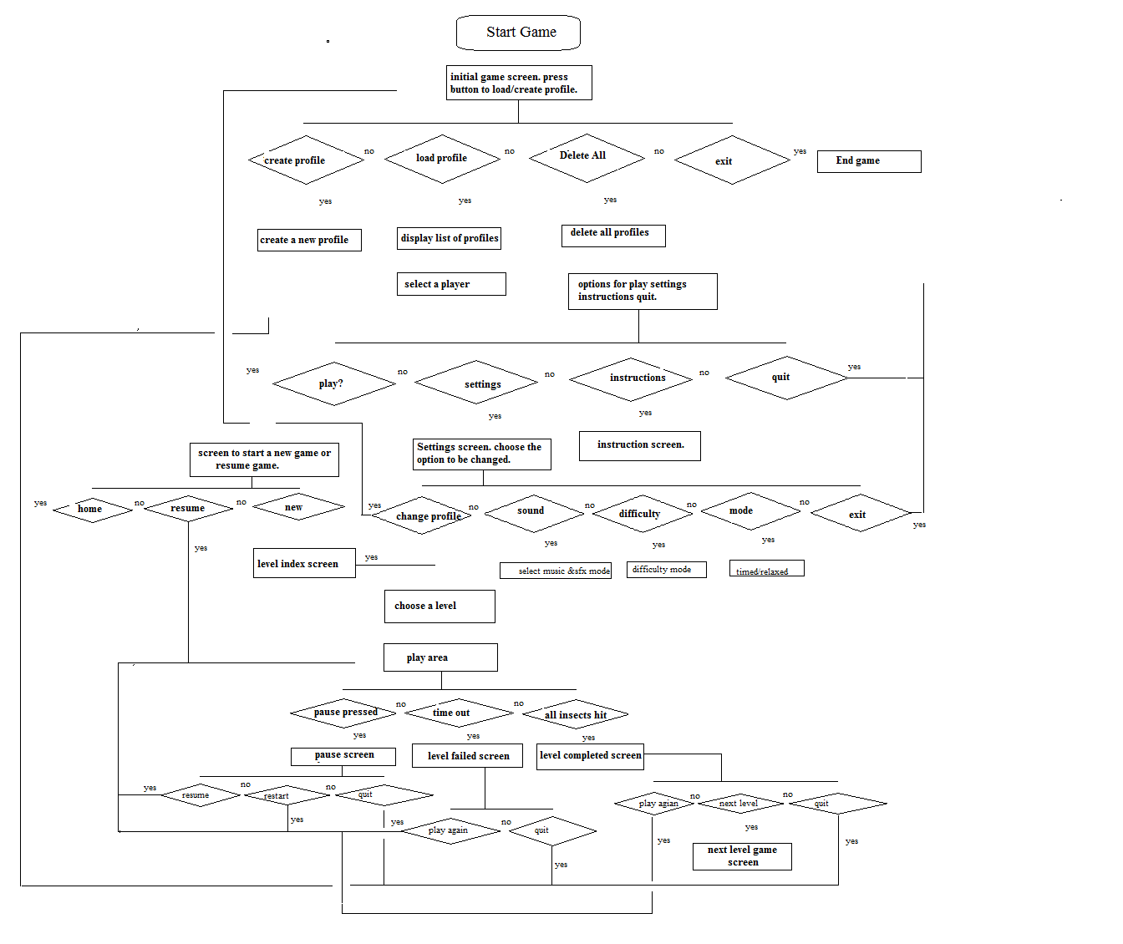

**4.2.2 Data Structures Description**

Database has been used to create profile of a player. The player is provided with an option to create profile, delete all profiles, view profiles along with their high scores. While creating a new profile user has to enter a unique name, which is stored in the database for later retrieval. Along with the profile name and score other information regarding the users gameplay and settings are also saved in the database, for example, level completed.

When a player selects load profile option the information is retrieved and is displayed. On selecting a profile among of these profiles for playing the game, the settings corresponding to that profile are loaded.

**4.3 User Interface Design**

**4.3.1 User Interface Overview**

**Initial Screen**

* On starting the application player is provided with the options – create profile, load profile.
* On selecting create profile user can create new profiles.
* On selecting load profile a list of previously created profiles will be displayed and player can select a profile among them.

**Home Screen**

Home screen consists of options such as play, settings, instructions and exit. On tapping play user can get to choose whether to resume the game previously quit or start anew game.

**Level Index Screen**

* On selecting new game, player gets this level index screen.
* Player can choose to play any of the unlocked levels.
* To unlock a level the player must complete the previous level successfully.
* On selecting the level, the game screen will start.

**Settings Screen**

Settings screen consists of options

* To change the profile.
* To on/off music and sfx.
* To select the difficulty level: Easy/Medium/Hard.
* To select the game mode: Timed/Relaxed.

**Game Screen**

The game screen consists of the following: A shoot button (to shoot bubbles) and a pause button (to pause the game).

**Pause screen**

The pause screen gives the following options: to resume the game which is currently being played, to restart the game or to quit to the main menu.

**Level Failed Screen**

This screen will appear if the player fails to complete the level. It provides the options to play the same level again or to quit to the main menu.

**Level Completed Screen**

The Level completed screen appears if the player successfully completes a level. It provides the options to

* play the same level again,
* proceed to the next level and
* simultaneously the next level is unlocked.

**4.3.2 User Navigation hierarchy**

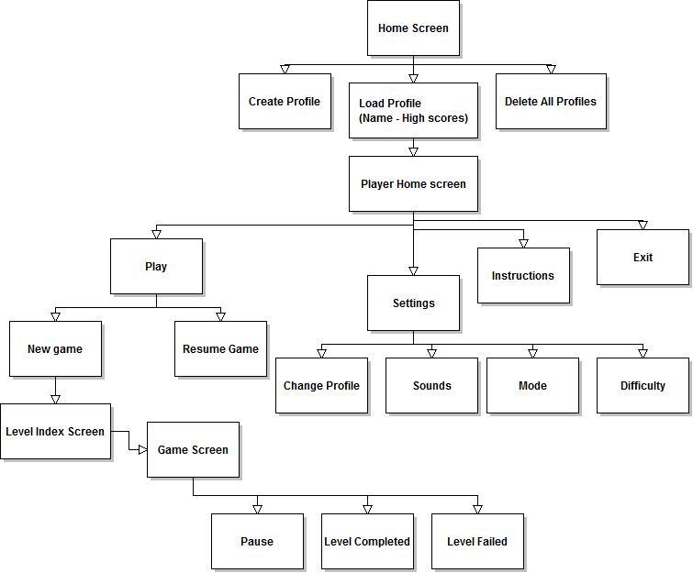

**5. Implementation**

**5.1 Module Description with Its input And Output**

**5.1.1 ArcherFishActivity**

This activity is the first activity that is started when the game is loaded. This activity consists of four buttons namely, create profile, load profile, delete all and quit. Clicking on any of the button redirects the user to a different module. Create profile button redirects to an activity for creating new profiles. Load profile loads all the profiles already created player can select any of these profiles for gameplay.

**5.1.2 SaveDataActivity**

This activity has a text field to take the player’s profile name. The name by which the player is creating his/her profile must be unique. The name with other information is saved into the database.

**5.1.3 CheckDataActivity**

This activity is started when the player selects load profile button from the ArcherFishActivity. It displays the list of all the profiles existing in the system along with their high scores, arranged in the descending order of their high scores, thus the player with the highest score will be at the top.

**5.1.4 HomeActivity**

This activity is started when user selects a profile he will be playing with. This is the home screen for the selected profile. It consists of Play button, Settings button, Instructions button and Exit button.

Play button starts an activity to choose whether to start a new game or resume the game from where it was left the previous time. Settings button starts the SettingsOptionActivity where user can change the gameplay settings.

**5.1.5 SettingsOptionActivity**

This activity is started by clicking on the Settings button. It provides the options to change profile, change sound settings, change difficulty level, change mode of gameplay (timed/relaxed).

**5.1.6 LevelIndexActivity**

This activity is started when player choose to play a new game instead of resuming his/her previous game. This activity consists of a list of all the six levels of the game. The player can choose to play any of the unlocked levels by clicking on the level number. To unlock and play the locked levels the user is supposed to successfully somplete the previous levels.

**5.1.7 PlayGameActivity**

On the basis of which level user has selected the PlayGameActivity will start. This activity consists of the game area. In all the levels, this activity, apart from the animations, this activity will have a pause button. Clicking on the pause button will start PauseGameActivity and the game will be paused.

The archer fish is present at the bottom of the screen inside the water body and there are insects flying around the water. On taping any location above the water level the fish will turn in that direction. On tapping any location below the water level the fish will change its linear position and will start moving towards the location tapped. There is a shoot button given in the bottom left corner of the screen, tapping which the fish will shoot water bubbles in the direction it is aligned. If the shot water bubbles hit an insect well enough, the insect will fall down into the water and the score will be incremented by ten points. Tapping on the fallen down insect the fish will move to that location and it will eat the insect further adding five points to the score.

Depending upon which level the user is playing and in which mode the user is playing (timed or relaxed) the game will terminate. If the player has scores sufficient points the level is completed and the next level is unlocked which user can play. But if the player failed to score sufficient points the level will be failed and the user will have to play the same level again, until it is not successfully completed.

**5.1.8 LevelCompleteActivity**

This activity is started when the user has successfully completed a level of the game. This activity consists of two options one to play the same level again or proceed to the next level. Also the next level is unlocked. The player can also quit to the main menu and the score of the player will be updated.

**5.1.9 LevelFailActivity**

This activity is started if the player fails to successfully complete a level. This activity consists of two options. First option is to play the same level again and the second option is to quit to the main menu.

**6. Testing**

**6.1 Test Plan and Test Cases**

**PHASE 1: Implementation of User Interfaces**

|  |  |  |  |
| --- | --- | --- | --- |
| TEST ID | INPUT DESCRIPTION | EXPECTED OUTPUT | ACTUAL OUTPUT |
| 1. | Press “create Profile” button. | A form screen to take profile info for the new profile to be created. | A form screen to take profile info for the new profile to be created. |
| 2. | Press “load profiles’’ button. | A list of all the profiles already existing. | A list of all the profiles already existing. |
| 3. | On pressing any of the user profiles in the displayed list. | New screen having options as Play, Instructions, Settings and Exit will appear. | New screen having options as Play, Instructions, Settings and Exit appears. |
| 4. | Press “Settings” button. | A new screen with various settings options, sounds, difficulty, mode, will appear. | A new screen with various settings options, sounds, difficulty, mode, appears. |
| 5. | Press “play” button. | A new screen having option for “resume game” and “new game” will appear. | A new screen having option for “resume game” and “new game” appears. |
| 6. | Press “new game button” | A new screen showing all the levels. In the game. Only unlocked levels will be clickable. | A new screen showing all the levels. In the game. Only unlocked levels are clickable. |
| 7. | Pressing an unlocked level button. | Game screen will appear. | Game screen appears. |

**PHASE 2: Implementation of 40% modules with first level completion.**

|  |  |  |  |
| --- | --- | --- | --- |
| TEST ID | INPUT DESCRIPTION | EXPECTED OUTPUT | ACTUAL OUTPUT |
| 1. | On starting a new game. | Game screen will appear with animations of flying insects. | Game screen appears with animations of flying insects. |
| 2. | On taping above the water level. | The fish will redirect itself in the direction of the tap. | The fish redirects itself in the direction of the tap. |
| 3. | On pressing the shoot button. | Fish will shoot water bubble in the direction it is aligned. | Fish shoots water bubble in the direction it is aligned. |
| 4. | The water bubble shot on pressing the shoot button. | If the bubble hits the insect, the insect will fall down into the water. | If the bubble hits the insect, the insect falls down into the water. |
| 5. | On tapping the insect fallen down into the water. | The fish will move to the location of the falling insect and will eat the insect. | The fish moves to the location of the falling insect and eats the insect. |

**PHASE 3: Implementation of 60% modules with three levels completion and switching from game area to levelComplete screen and Level fail screen.**

|  |  |  |  |
| --- | --- | --- | --- |
| TEST ID | INPUT DESCRIPTION | EXPECTED OUTPUT | ACTUAL OUTPUT |
| 1. | On tapping a location inside the water. | The fish will move linearly to the location of the tap. | The fish moves linearly to the location of the tap. |
| 2. | On pressing the shoot button. | Fish will shoot water bubble in the direction it will be aligned. If it hits an insect score is incremented by 10 points and the insect will fall down into the water. | Fish shoots water bubble in the direction it is aligned. If it hits an insect score is incremented by 10 points. |
| 3. | On tapping on the insect fallen down in the water. | The fish will move to the location of the insect and the score will be incremented by 5 points. | The fish moves to the location of the insect and the score is incremented by 5 points. |
| 4. | After the timer expires and score is less than 150 points. | The level will be failed. | The level is failed. |
| 5. | After the timer expires and score is more than or equal to 150 points. | The level will be completed the user proceeds can proceed to next level. | The level is completed the user proceeds can proceed to next level. |
| 6. | On pressing the pause button. | A new pause screen will appear with options to resume game, restart new game and exit. | A new pause screen appears with options to resume game, restart new game and exit. |

**PHASE 4: Implementation of 80% modules with proper user profile implementation.**

|  |  |  |  |
| --- | --- | --- | --- |
| TEST ID | INPUT DESCRIPTION | EXPECTED OUTPUT | ACTUAL OUTPUT |
| 1. | Press “next level” button after completion of level 1. | Game screen for level 2 appears. | Game screen for level 2 appears. |
| 2. | On loading a particular user profile. | Settings for that User profile will be loaded and the game will be played with these settings only, until they are not modified. | Settings for that user profile are loaded and the game is played with these settings only, until they are not modified. |
| 3. | On pressing “resume” game button. | The game starts from the same point where the user left before quitting the last time. | The game starts from the same point where the user left before quitting the last time. |
| 4. | Pressing any of the unlocked  Level buttons. | The game screen for that level will start. | The game screen for that level starts. |
| 5. | Score: on loading the list of profile. | The user profiles will be displayed in the descending order of their scores. The user having the highest score will be at the top. | The user profiles are displayed in the descending order of their scores. The user having the highest score will be at the top. |
| 6. | On pressing back button in the game screen. | A warning dialog box appears asking the user whether to quit the game or continue playing. | A warning dialog box appears asking the user whether to quit the game or continue playing. |
| 7. | On pressing back button on any other screen. | The screen previous to the current screen appears. | The screen previous to the current screen appears. |

**PHASE 5: Completion of all the modules with proper navigation, quitting from the game and device independence.**

|  |  |  |  |
| --- | --- | --- | --- |
| TEST ID | INPUT DESCRIPTION | EXPECTED OUTPUT | ACTUAL OUTPUT |
| 1. | After completing a level. | The user’s score will be updated. | The user’s score is updated. |
| 2. | On making any changes to the user settings. | The new settings will be saved for that user. | The new settings are saved for that user. |
| 3. | After completion of one level. | The next level will be unlocked and user can play the next level. | The next level is unlocked and user can play the next level. |
| 4. | Total score: After completion of a level. | Total score after completion of one level will be equal to the sum of score until previous level and the score of the current level. | Total score after completion of one level is equal to the sum of score until previous level and the score of the current level. |
| 5. | On pressing “Exit” button. | The game will terminate. | The game terminates. |

**7. Results**

**7.1 Navigation**

* Proper navigation on clicking of each button.
* On clicking quit from any activity but the home activity the home page appears.
* On clicking back button, anywhere but the game area, of the phone/emulator the activity previous to the current activity starts.
* On clicking back button in the game area, the game is paused and a dialog box appears asking for confirmation if the player wants to quit the game or resume. On choosing quit, the home page activity is started.
* After the completion of the game, depending on the score and the timer the LeveCompleteActivity starts or LevelFailActivity starts.

**7.2 Profile**

* A profile of each player is being properly maintained.
* The score and the level information of every profile is properly updated as the player moves to higher levels.
* Profiles are listed on the basis of their high scores. The one with highest score gets the first place and so on.

**7.3 Play Area**

* On clicking on the surface inside the water the fish will linearly move to that location.
* On tapping on the surface above the water level the fish will turn in that direction.
* Tapping on the shoot button the fish shoots a water bubble in the direction it is aligned.
* If the bubble hits an insect well enough the insect will fall down into the water.
* Tapping on the fallen down insect the fish will move to that location and eat the insect.
* When the pause button is hit. The game is paused and PauseGameActivity is started.
* Depending on the score and the time, a level is successfully completed or failed.

**8. Conclusion and Future Scope**

**8.1 Conclusions:**

* The player can the game by maintain his/her profile.
* The player can play the game with whatever settings he/she likes.
* The player can save and quit the game at any point of time. The game can be resumed from the same time.
* After completion of a level the next level will be unlocked.
* The player with the highest score will be at the top of the list of player profiles.

**9. References/Bibliography**

1. Hello, Android – Ed Burnette, 3ed.
2. <http://www.edu4java.com/androidgame/>
3. <http://www.developer.android.com/>